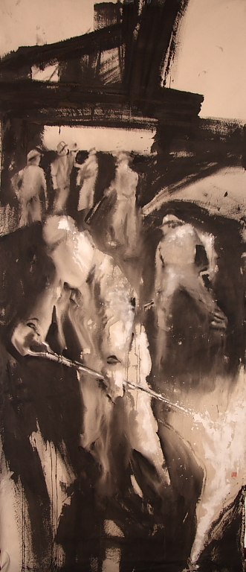 |   Saturday June 19th 2010  from 10 a.m. to 7 p.m.  ODRZ06 Live  Industrial Music Performance  A whole working day in a factory  ODRZ06: the project  The ODRZ06 project starts in 2002 and it is a musical rendering (industrial noise) of a day in a factory. The work symbolises the whole working day (in Italy 8 working hours and 1 lunch break hour) and it is made up of 9 parts.  Each part has been published by the Norwegian label Tibprod Records (www.tibprod.com) on a fixed day, May 1st of every year starting from 2004.  The work has been completed on May 1st 2010.  Factory engines and surroundings have been sampled during working time and have been subsequently altered. The samples have been used across the entire work: sounds of analogue synthesizers, microphones, effect units and voices have been added too.  ODRZ06: live performance  The opera will be played entirely live by ODRZ except for lunch break hour (from 2 p.m. to 3 p.m.), that will be spread by CD.  Screenings and exhibitions during the performance:  - videos supplied by Fondazione Ansaldo of Genova;  - videos made with photos of Archivio del Lavoro of Sesto San Giovanni (MI);  - photos of Archivio del Lavoro of Sesto San Giovanni (MI);  - paintings by Stefano Giorgi, painted expressly for ODRZ06 Live.  Live actions during live event  Dance: Elena Pellegatta  Marcella Fanzaga (http://www.marcellafanzaga.it/)  Paintings: Stefano Giorgi (www.stefanogiorgi.altervista.org)  www.odrz.org odrz@odrz.org  BLITZ  via Cosenz 44/4  zona BOVISA MILANO

