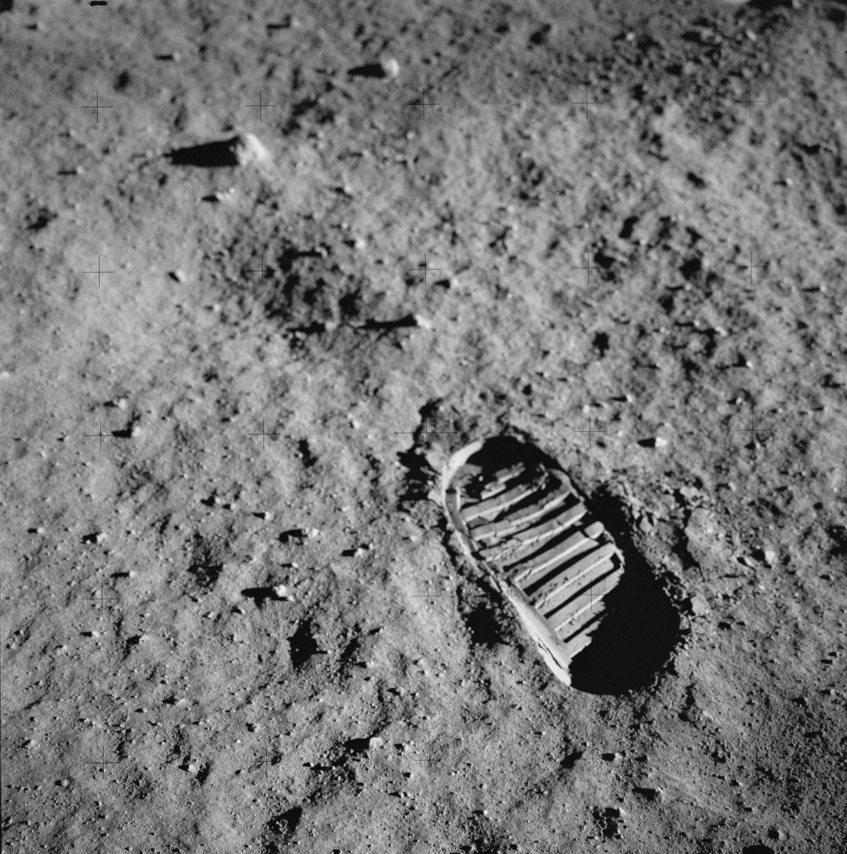
July 20, 1969

Ar...Arr…Armstrong…
I can’t even pronounce that name today.
In 1969 I was 7 years old and probably understood better than my father what was happening.
We were all stuck to that wooden box that weighed a ton with 2 wheel selectors that had 5 positions but we only used 2.
Ar… Armstrong.
Continued trying to repeat my father.
I, I wasn’t interested in him because the first thing that would have touched that ground that was no longer my Moon would have been the caterpillar shaped sole of a shoe.
With those big and polished boxes whose shine reached our house on his shoulders, the commander of the mission Armstrong was just about to start the first, the first and I repeat first, walk ever of a man on the Moon.
Poor Jules Verne…could he at least be here with us, in our house, to see what was happening on his Moon, instead of standing still on the library inside his: FROM THE EARTH TO THE MOON.
The descent of the ladder, of those light rungs, down to our house, was never ending.
COLLINS…
I didn’t know he was with Aldrin. I wasn’t able to say Armstrong let alone the other two.
My father told me to raise the volume with a simple motion of the hand, no one could speak that evening during the live broadcast.
Ten twenty three an impossible time for me if I had wanted to watch any other show, but the landing on the Moon…
Armstrong.
I can’t pronounce it even now.
I moved without making any noise, everyone was seated on the sofa watching the landing, while I balanced myself on the armrest like a real astronaut. My father, my mother and my brother with my bored sister next to him thinking about who knows what, looked at me every once in a while asking me to sit still.
I stood up to raise the audio and, maybe the excitement or the exhaustion, but I know it was that sole that distracted me, instead of turning the volume knob, I pressed the on/off switch.
Armstrong, Collins and Aldrin with the whole LEM disappeared in a small black hole of the cathode-ray tube.
I turned for an instant, I couldn’t avoid it and I looked at my father and at all the others, the eye of the screen reduced exactly like theirs,
“If it closes completely I’m finished” I thought, it takes about ten minutes for that thing to switch on and they are there and they are not waiting for me but for Armstrong.
“TAC” and pressing with the sweaty hand I recapture the ether nearly immediately.
– Armstrong hasn’t yet stepped down with both feet! Ooops…there –
I managed to say breathing after a few minutes of pure apnoea.
No one spoke, no one looked at me, I think my father regretted having allowed me and my brother to watch the live broadcast of a piece of history that, according to him, would have changed the future.
It was only an instant and without ever saying anything, as during the entire evening, he nodded with the head inviting me to move and sit down to avoid other problems.
Armstrong we all said releasing emotion with Tito Stagno and whilst my family and the most part of planet Earth drew on Armstrong’s memorable phrase: “That’s one small step for man, one giant leap for mankind”.
At the word ‘step’ I thought about the caterpillar shaped sole all night, the only thing to have really touched lunar soil.

Castrenze Calandra

